Stefan Cline

Homework #5

Math 636 – Mathematical Modeling

23 September 2021

Exercises

50: 8, 13

54: 2, 6, 11

**Problem 50.8:**

An alternate predator-prey model was suggested by Leslie:

The equation for prey is the same. However, the predators change in a different manner. Show that if there are many predators for each prey, then the predators cannot cope with the excessive competition for their prey and die off. On the other hand, if there are many prey for each predator, then the predator will find them and increase. Do you have any objections to this model? Compare this model to the Lotka-Volterra model.

Here if we’re starting by assuming that , then we should expect a catastrophic decrease in the shark population. We’re effectively assuming that the sharks kill/eat enough of the fish population while fighting to survive that we’d expect in reality that the prey fish population would be decimated past the point of recovery, i.e., the sharks would hunt them to extinction then themselves perish. This is observed in a pplane8 plot from MATLAB. However, the difference is the model, because is an unstable equilibrium) predicts an eventual rebound in the population.

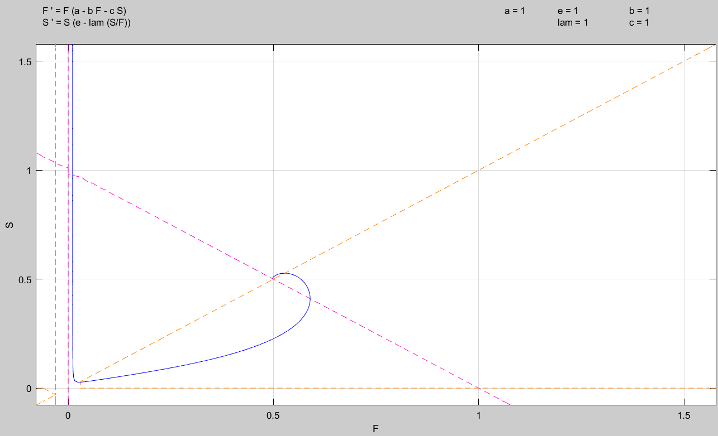

A basic analysis of the isoclines for the above plot reveal that this general shape will occur unless we assume a zero population (which isn’t of interest) for either fish or sharks.

To show this, we’ll find the infinity and 0 isoclines. Infinity:

Now for the second equation, zero:

Therefore, we see that we will always have a case of an isocline starting at the origin, and then an isocline that starts at a positive point on the -axis, and then has a negative slope. Therefore, the isoclines shown in the above photo will always be the case.

My objection to the model is that there is no “total death” scenario and assumes that the fish population somehow can always rebound regardless of how low its population becomes. Even if we have infinite sharks, once enough of them die, somehow enough fish survive to simply come back and repopulate. This also could be a bad model because it always assumes some amount of sharks survive to keep eating the fish. If there is no food, they should all die off relatively quickly before there would be enough to sustain themselves on. So again, near the extremes the model possibly should show death for both or the sharks but always shows a trend towards the equilibrium point.

The second scenario is far more likely. If there is a large population of fish, you’d expect that if there are enough sharks to breed, that they’d have ample enough population to grow in numbers and plenty of prey fish to consume. We can see this easily with another pplane8 model from MATLAB. Here we select a starting population with low shark numbers and high fish numbers:

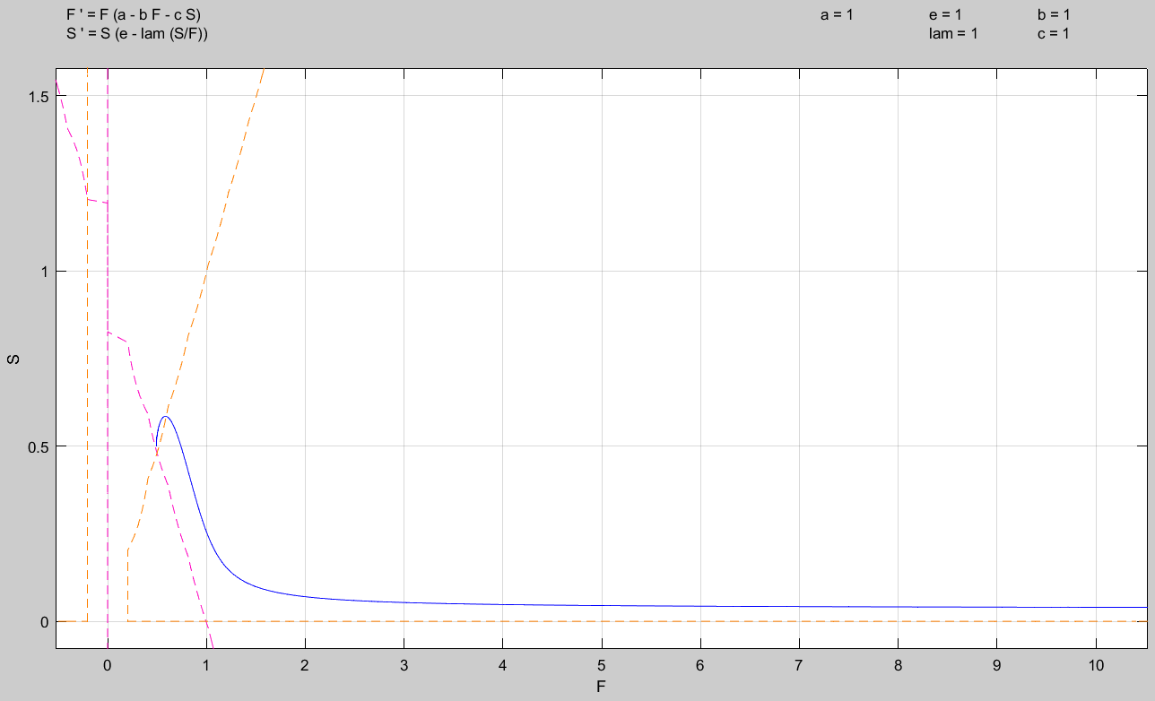

The Lotka-Volterra Model:

Finding the isocline equations again:

Infinity:

Zero:

So now we have three different scenarios for our various outline of the isoclines. The general scenarios are shown before, with the critical points in question.

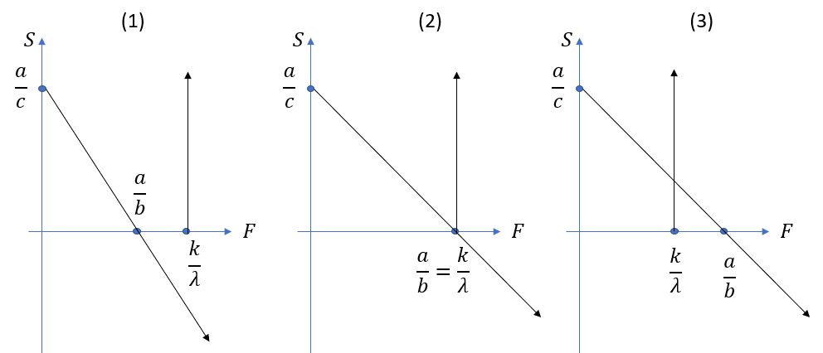

Immediately we see that this model gives us more diversity in outcomes.

(1)

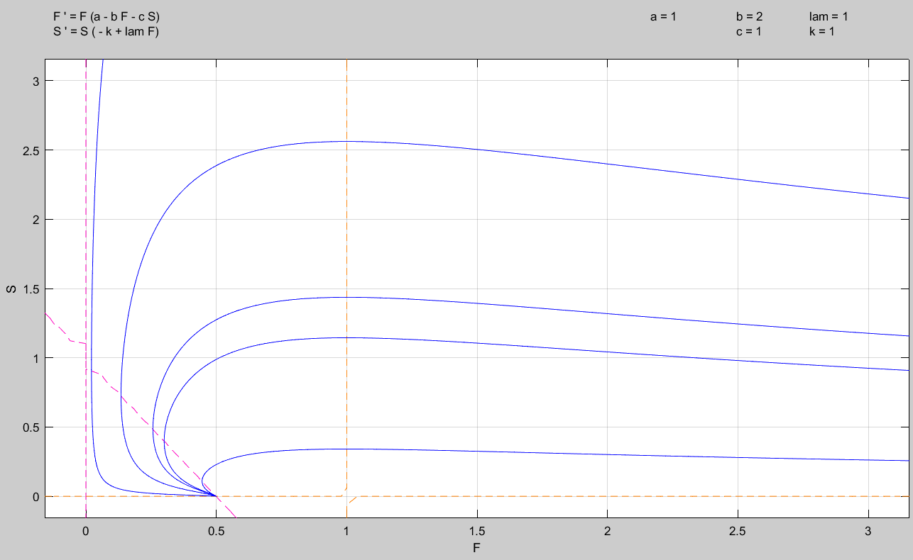

(2)

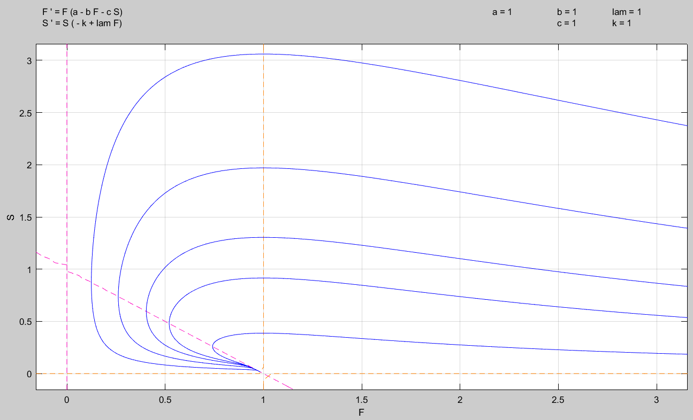

(3)

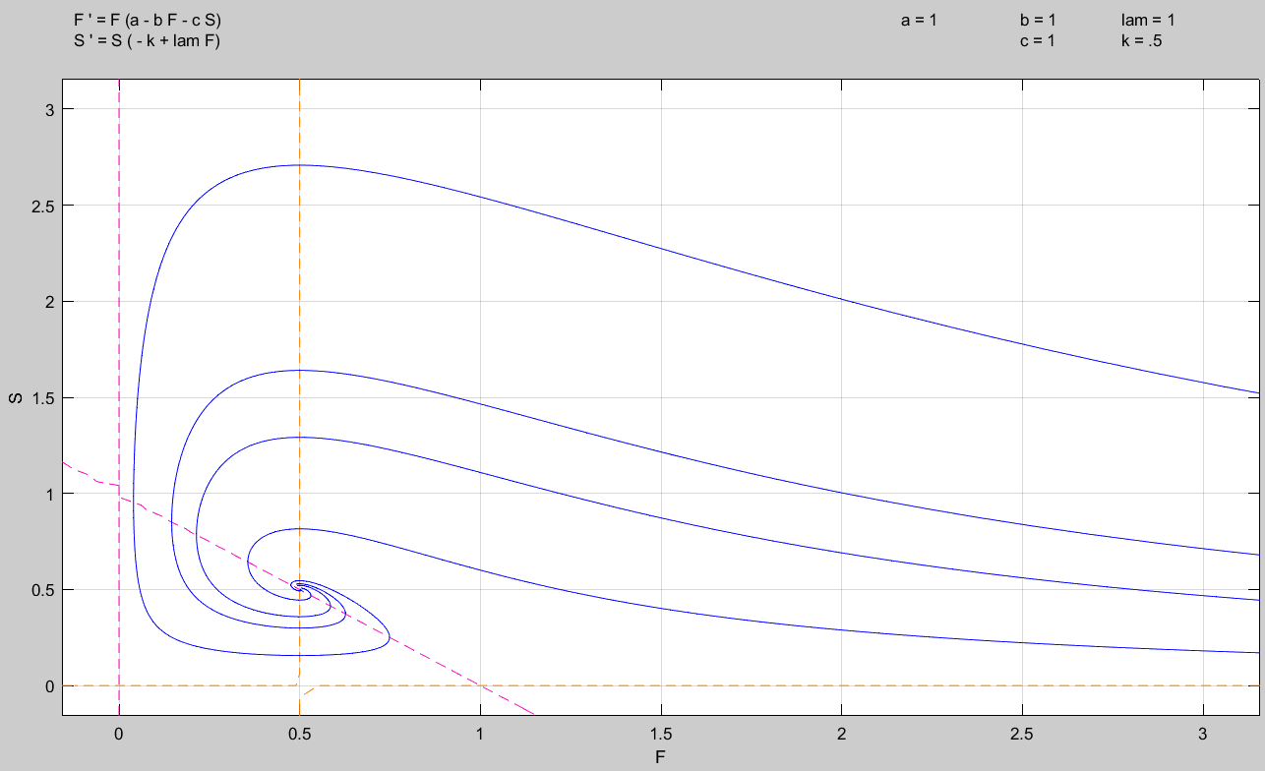

Comparing the above to Leslie’s model, we see that they have different strengths and weaknesses. In one model, it shows that if a birth rate is too low, then no matter what the sharks hunt a species of fish out of extinction even with relatively “normal” starting conditions. This could be possible but seems less likely. However, this model (LV) captures the idea that a species can die out given certain conditions better than Leslie’s (as Leslie’s doesn’t do it at all). Both however, given specific parameter choices, provide for stable non-zero equilibrium solutions.

**Problem 50.13:**

Reconsider 50.12.

(a) Sketch the phase plane in the neighborhood of the equilibrium population in which both populations are nonzero.

We first need to determine what the equilibrium populations are. Therefore, observing our two functions:

We clearly have: . Also, we see , produces:

So, our other equilibrium points are:

Now, setting the two solutions equal to one another to produce our final equilibrium point, :

Placing this into the other equation:

Placing this back into the equation with :

We note then that our denominators cannot be zero, i.e.:

So,

Now, because we’re assuming that our exists (i.e., our non-zero population equilibrium point), we must have a case in which we have intersecting isoclines. Therefore, we’ll find our 0 and isoclines.

So,

Zero isocline:

Infinity isocline:

This gives us the following analysis: we must have . If we don’t, our isoclines will have an equilibrium point that requires a population to be less than zero, which is clearly impossible.

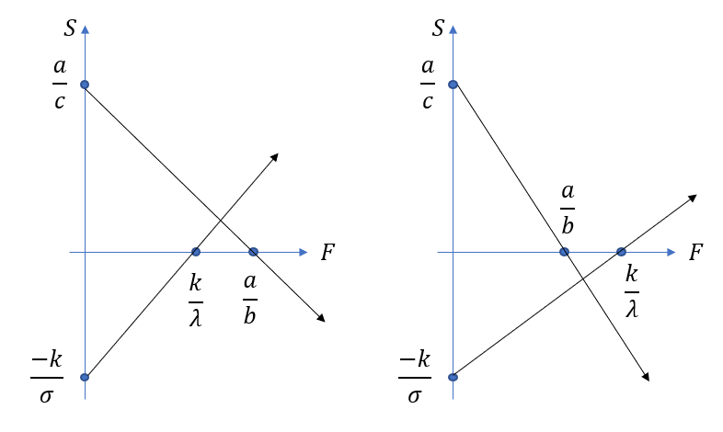

This effectively locks in the general shape of our phase-plane. Using MATLAB to sketch a phase plane for us gives:

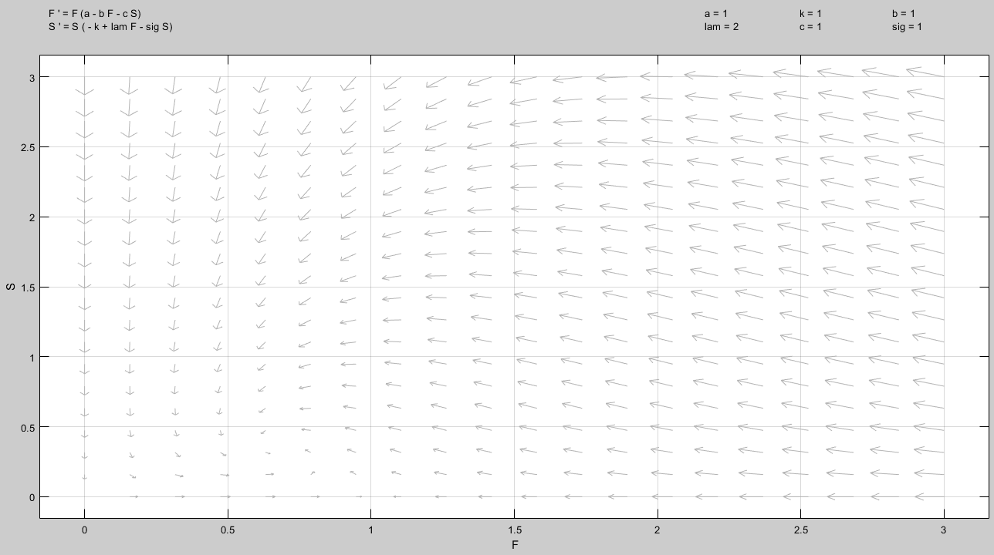

Using the Jacobian, we can easily determine the stability of our points and . We know that:

Subtracting the eigenvalues, let’s call them :

Case I:

Clearly, we have a positive and negative eigenvalue. Therefore, we know that is a saddle node on these two axis’.

Case II: :

Where (we know that from the setup that . Therefore, again we have a case of one positive and one negative eigenvalue. So, if there is no shark population the fish population converges to this value.

Case II: :

We can see here that both eigenvalues will be negative when solved, so if one is set with the axis, we know it will still converge to zero. (This makes sense, no food results in total shark death.)

We’ll now use our isoclines and the picture above to pick points that will help us prove the general values of our direction field in the zones created by our isoclines. We note immediately that we discard negative population values.

If we pick as our first point (1), we can evaluate it in our differential equations:

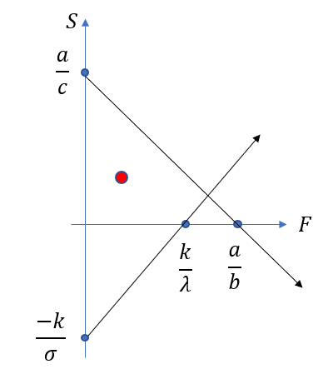

Now, picking (2):

Picking (3):

Picking (4):

Now, updating our picture gives:

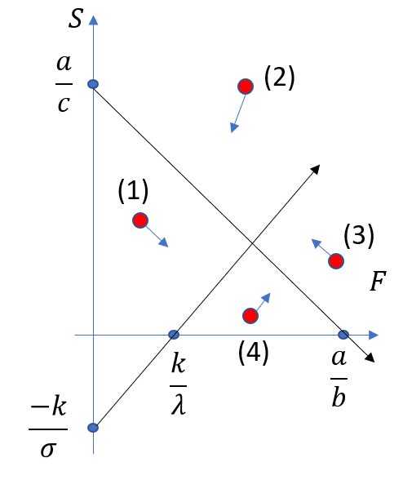

Therefore, we’ve analytically shown that around our equilibrium point, by analyzing our isoclines, that we have an inwardly spiraling shape as was shown earlier using MATLAB. (Effectively we’ve confirmed that the image drawn by MATLAB is something we can trust and use, not just blindly accept.)

(b) Sketch the phase plane in the neighborhood of (What is the ecological significance of this population?)

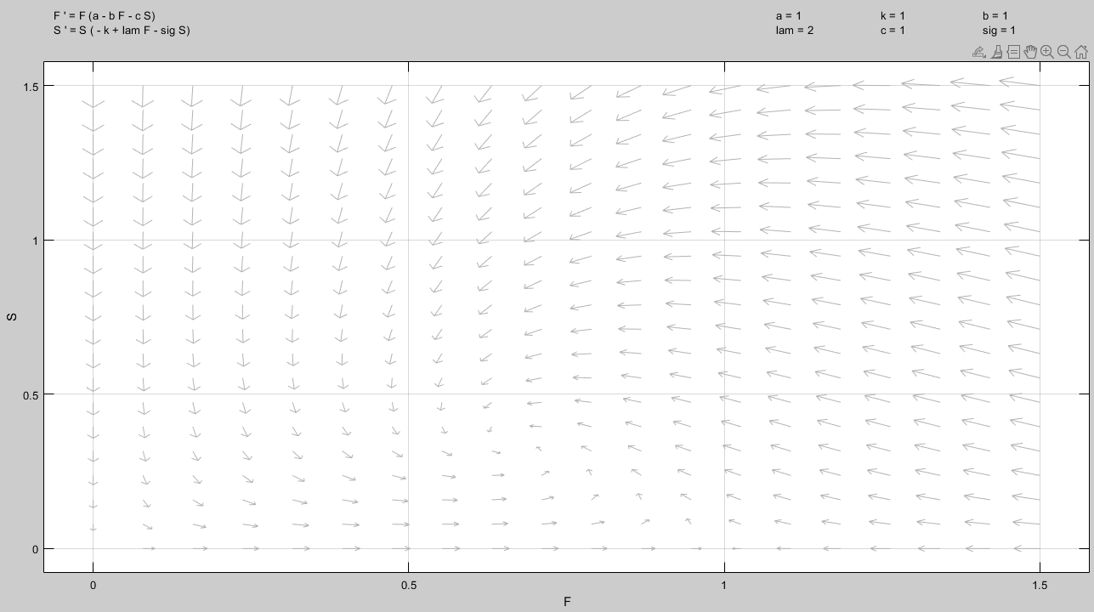

The ecological significance of this point is that the model doesn’t allow for exponential growth or unchecked growth. The prey fish, regardless of them having predators or not, will equilibrate at the point (in the drawing above this occurs at (0,1) but will be generically for whatever parameter values are chosen.

Also, above we’ve already shown this is an equilibrium point for .

(c) Sketch the phase plane in the neighborhood of .

We’ll simply reuse the same picture. Again, it shows an unstable equilibrium and saddle node.



(d) Use the information gained from parts (a)-(c) to sketch the entire phase plane. Describe the predator prey interaction. Sketch typical time dependence of predators and prey.

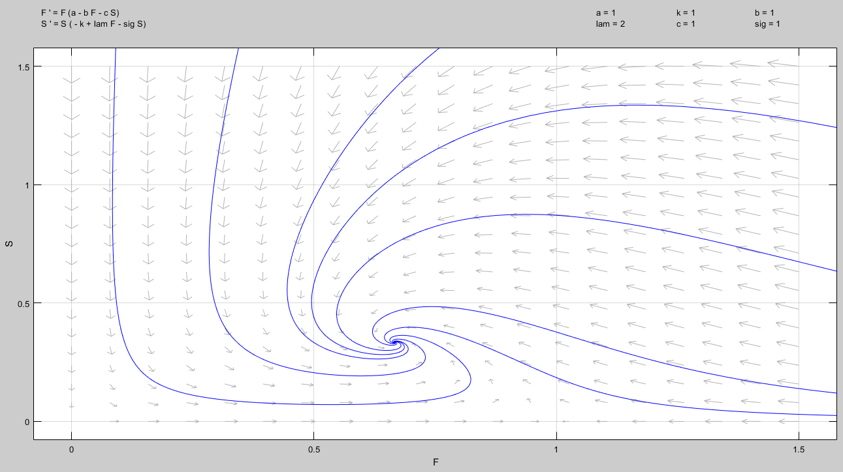

Here we have a situation where so long as the populations aren’t zero, they’ll settle on some equilibrium value. If one of the populations is zero, we’ll have total extinction (i.e., no prey fish so the sharks starve) or prey fish population equilibrium (i.e., no sharks to hunt them but they don’t have exponential population growth).

**Problem 54.2**

Consider the competing species model, equation 54.1. Sketch the phase plane and the trajectories of both populations if

1. and

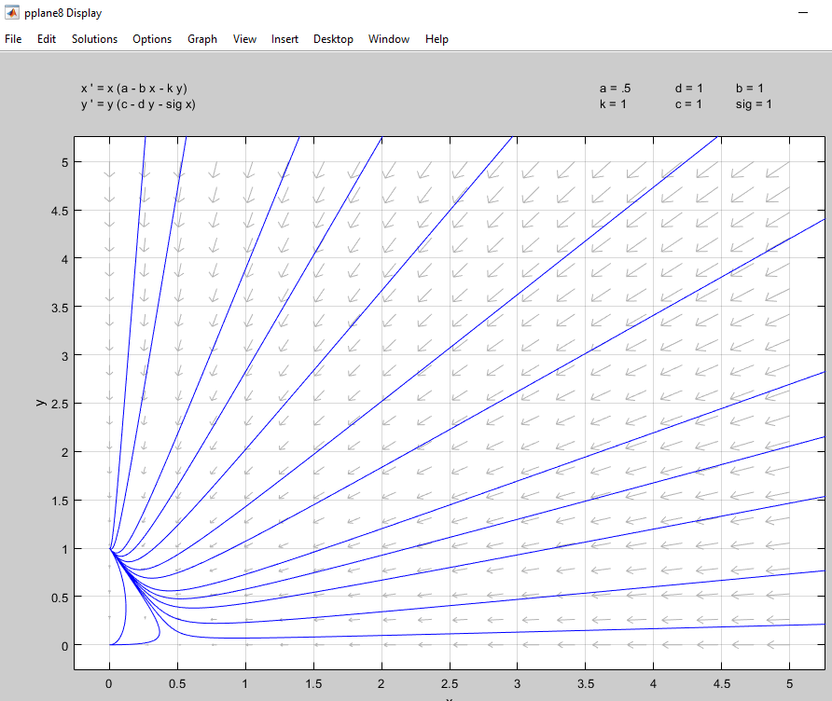

Here we see that species y wins out and stabilizes at a population value.

1. and

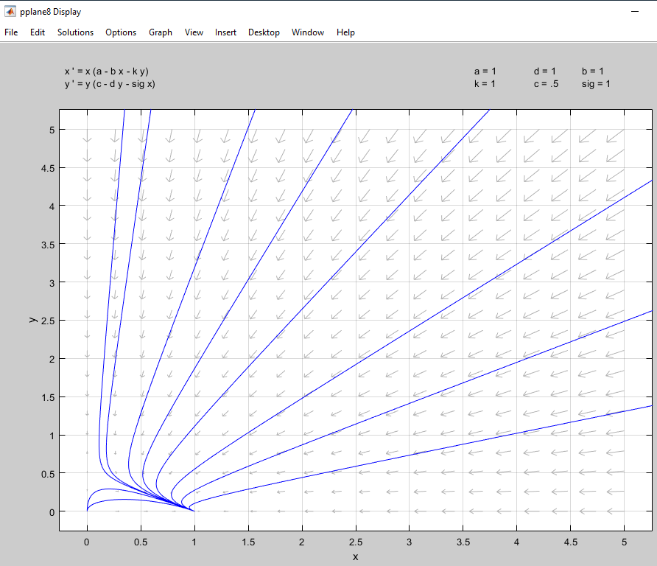

Here we see that species x wins out and stabilizes at a value.

1. and

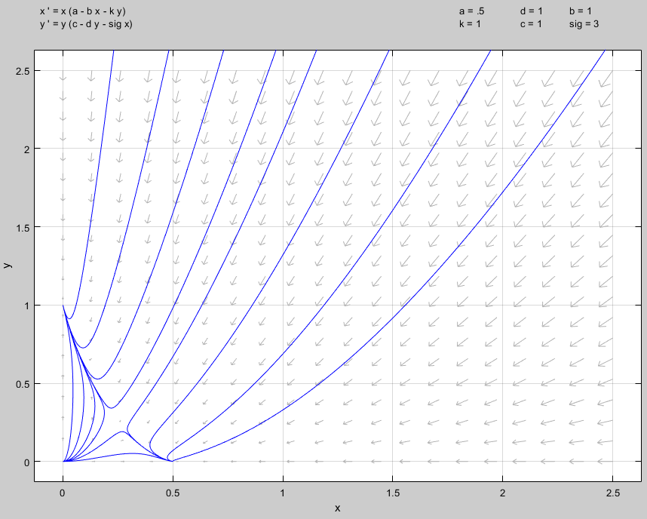

Here we see that the initial conditions are critical and that the equilibrium position is highly unstable. If there are slightly more of one species than the other, eventually one of the species will win out and settle at a fixed value.

1. and

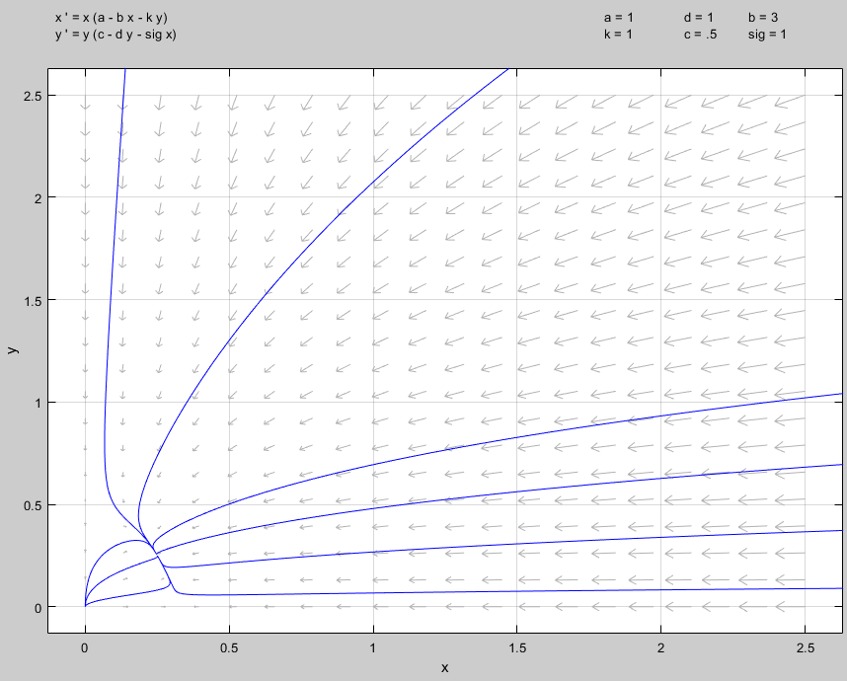

Here we see that regardless of initial conditions, the competition leads to a stable equilibrium for both species at some fixed value.

1. and

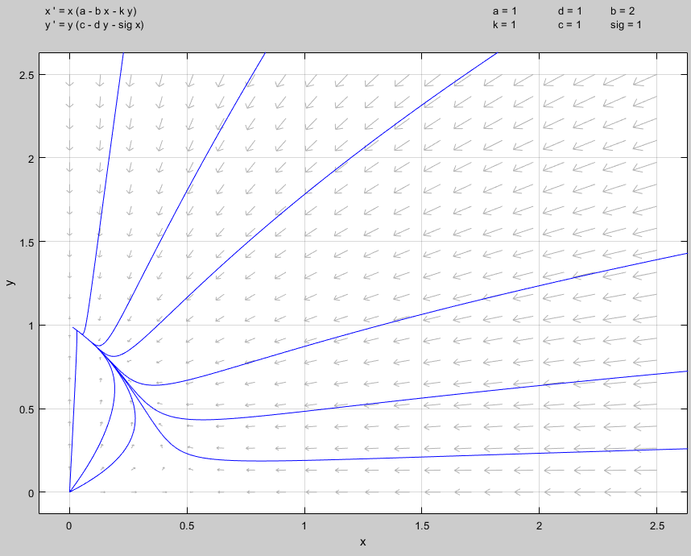

Here we see that the species mutually decline at certain values towards some fixed point, but that eventually a tipping point occurs and the y species wins out.

1. and

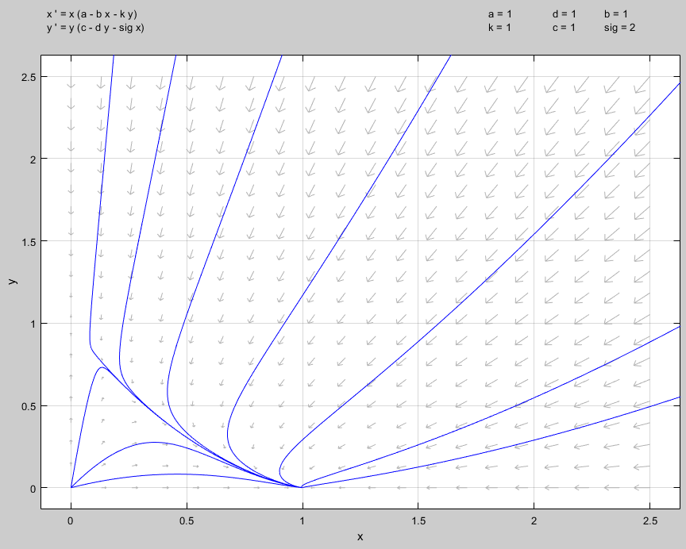

Here we see that the species mutually decline at certain values towards some fixed point, but that eventually a tipping point occurs and the x species wins out.

1. and

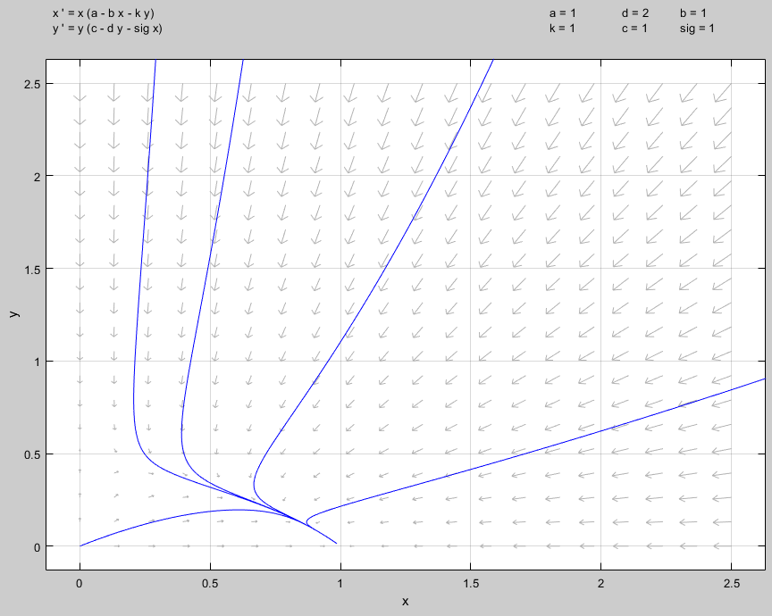

Here we see that both species compete somewhat evenly depending on their initial starting positions but eventually species x wins out. Effectively the populations almost linearly head towards the nullcline then rapidly decrease towards x’s winning value.

1. and

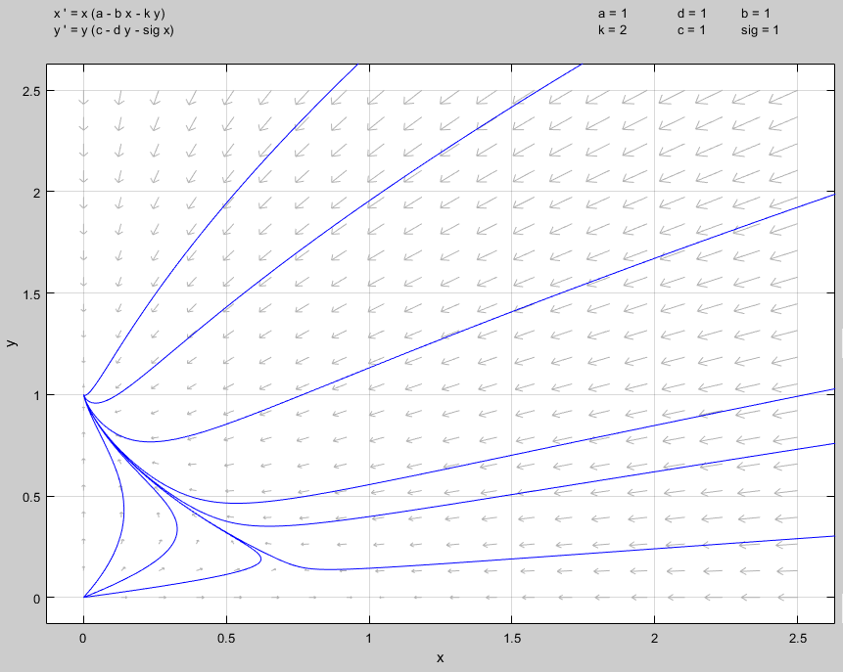

Here we see that both species compete somewhat evenly depending on their initial starting positions but eventually species y wins out. Effectively the populations almost linearly head towards the nullcline then rapidly decrease towards y’s winning value.

**Problem 54.6**

Consider the competition between two types of yeast described by equation 54.6. Can you predict the outcome of the competition? If , which yeast has the highest tolerance of alcohol?

The model for the two competing yeast populations:

Let’s first try to find any equilibrium populations. It’s clear that is one, but that is trivial. We move on to the case of no yeast population for then . Therefore, setting one variable equal to zero, then the other:

Now, looking at the system of equations and determining their isoclines:

For the isocline:

For the isocline:

Therefore, we see these isoclines are identical and produce infinitely many equilibrium solutions when but have no equilibrium solutions if .

Now, it’s easy to see that if then the yeast will win out. We can see this from observing the equations directly. They’re identical in set up, but if the shared component (i.e., the results in greater decrease for one or the other, it will “pull” the solution towards favoring one of the yeast populations). Here, and will push values around on the nullcline, but the delta of the will be the exponential deciding factor.

Testing an example directly of we have from pplane8 in MATALB:

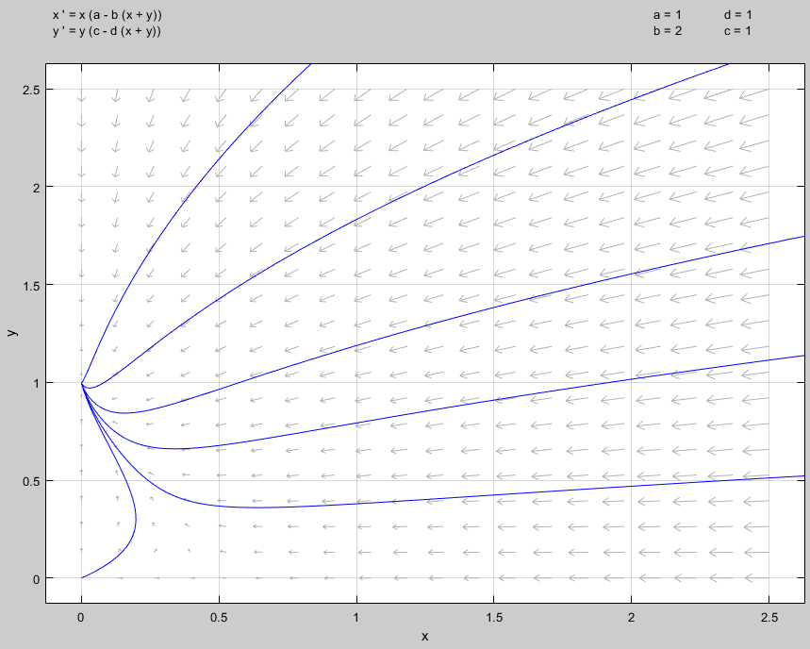

As expected, the yeast wins out and clearly has the higher alcohol tolerance. But we can do this by drawing the lines on our isoclines and seeing how they’ll effect the solutions. With we’ll have the following isoclines:

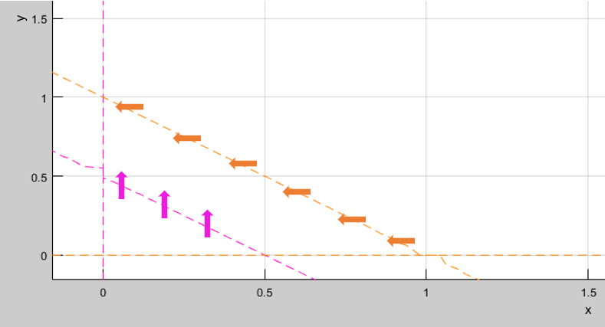

This shows us the general behavior in this instance.

**Problem 54.11**

Consider

(a) Give a brief explanation of each species’ ecological behavior. (Account for each term on the right hand side of the above differential equations.)

Here we see that both RHS’ of the above system of differential equations are effectively controlled by their current populations. That is, for both populations of and , they are reduced when their population is too large, but aided to increase by the population of the other when they’re smaller. This could be because they either eat each other, or do something where the byproduct is a boon to the other’s survival. Also, the 1 and 2 in the equations act as a “control” point. Neither population will be able to dip below 1 and stay there as they will always have some constant term propping them up. (1 for both because and .)

(b) Determine all possible equilibrium points.

Here we have the trivial . Also, if we assume and want to find an equilibrium point for then:

Likewise, for :

Therefore, our other two equilibrium points are (in the form ):

Observing a pplane8 direction field from MATLAB we see:

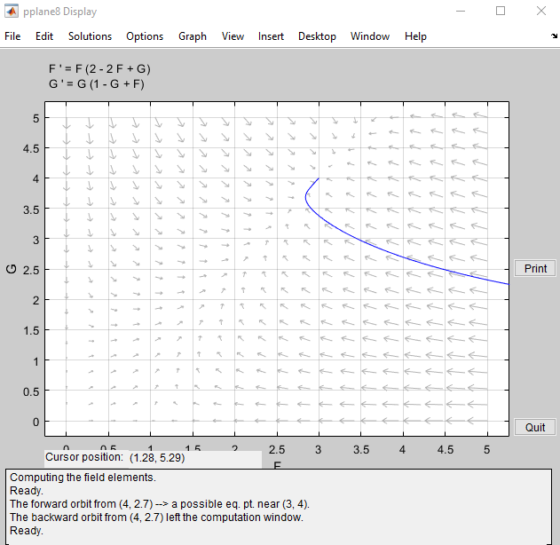

This appears to be an equilibrium position at . Testing this in our equations:

As such, we can conclude this is another fixed point.

In summary:

Lastly, we can find the isoclines to make sure we’re not missing any potential points:

So again, we see both of our lines.

Infinity:

Zero:

Plotting this (using ), and we see again our intersection equilibrium point of . This means we’ve again verified the 4 total equilibrium points.

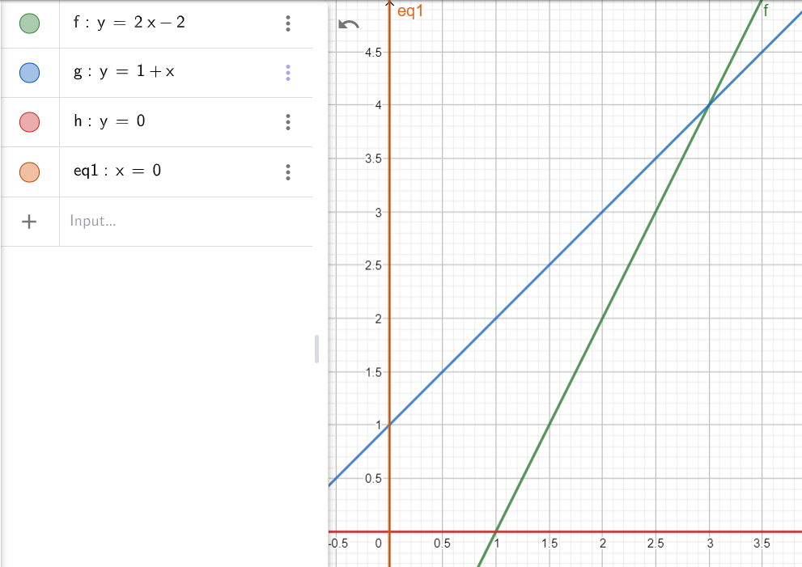

(c) In the phase plane, draw the isoclines corresponding to the slope of the solution being 0 and .

This is a repeat of the work we did above. Here we’ll simply offload this to MATLAB. The two isoclines circled in red is the infinity line, and in blue, the 0 line.

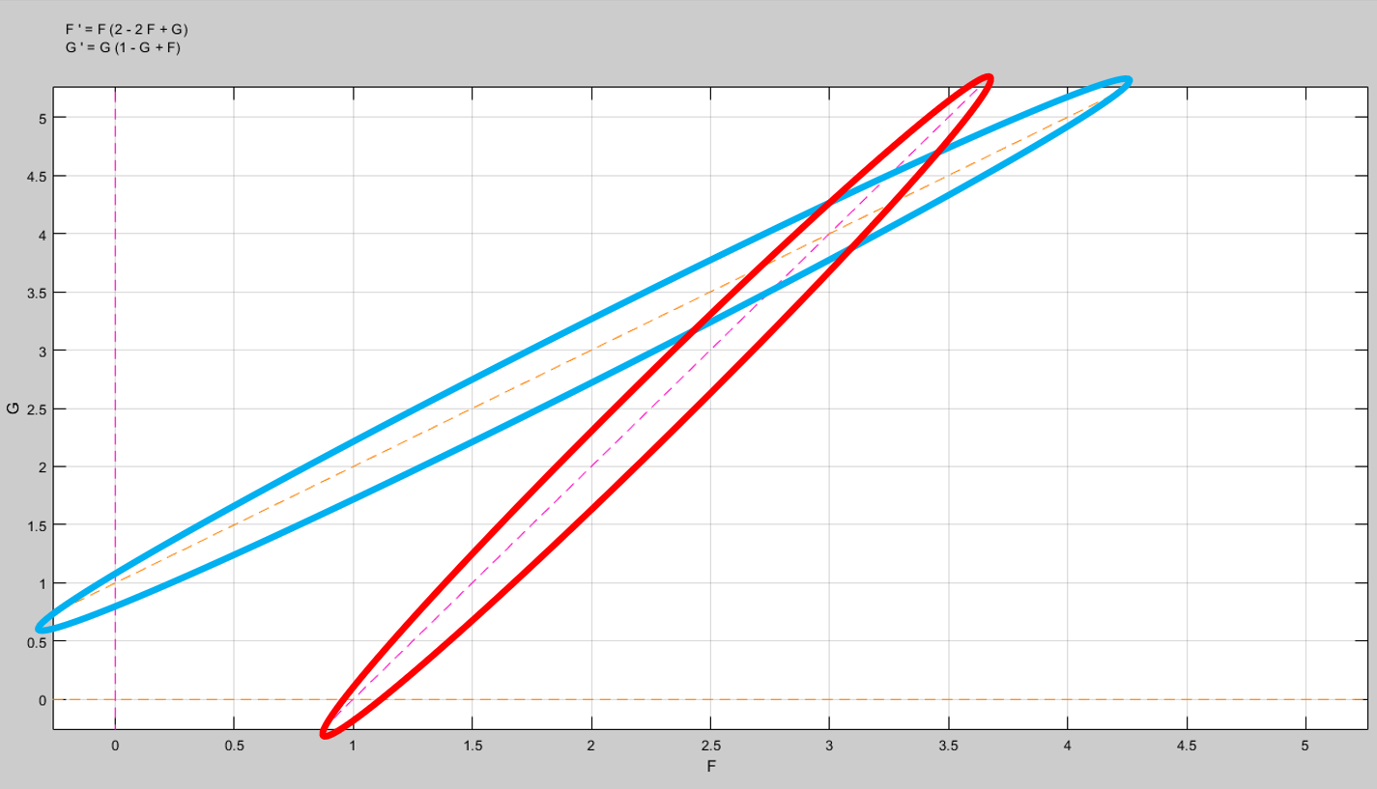

Analytically we see this as when we have:

So, for , we have:

Now for :

(d) Introduce arrows indicated the direction of trajectories (time changes) of this ecosystem. The qualitative time changes should be indicated everywhere in the phase plane.

Thanks to MATLAB this is a trivial task.

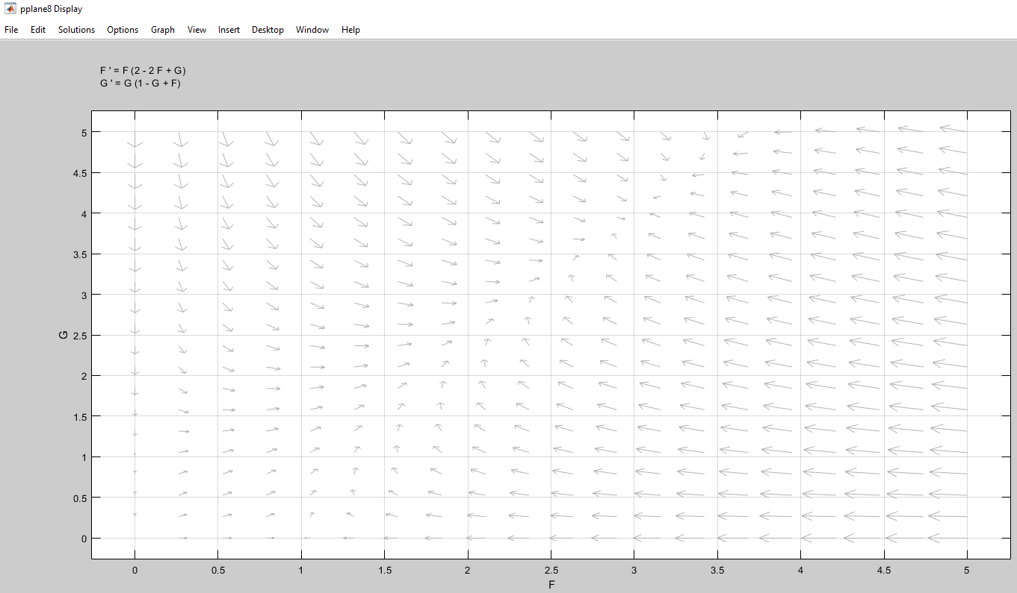

(e) From the phase plane in part (d), briefly explain which (if any) of the equilibrium populations is stable and which unstable. Do *not* do a linearized stability analysis.

We see the arrows converging to our equilibrium point for almost every scenario. Therefore, we clearly see that is a stable equilibrium.

We also see that is unstable, as lines on the axis, and lines in any direction away from it are going away from .

Interestingly, we see that we have two saddle nodes at and . If the populations lie exactly on the or axis, we see they converge to and remain at those points respectively. However, if both of the populations are non-zero, they trend away from and .

In summary:

|  |  |
| --- | --- |
| Point | Stability |
|  | Unstable |
|  | Semi-Stable / Saddle Node |
|  | Semi-Stable / Saddle Node |
|  | Stable |